HIGHLIGHTS @ Sanshil Foundation Project BAGIYA
Effective JANUARY 2018-November 2018

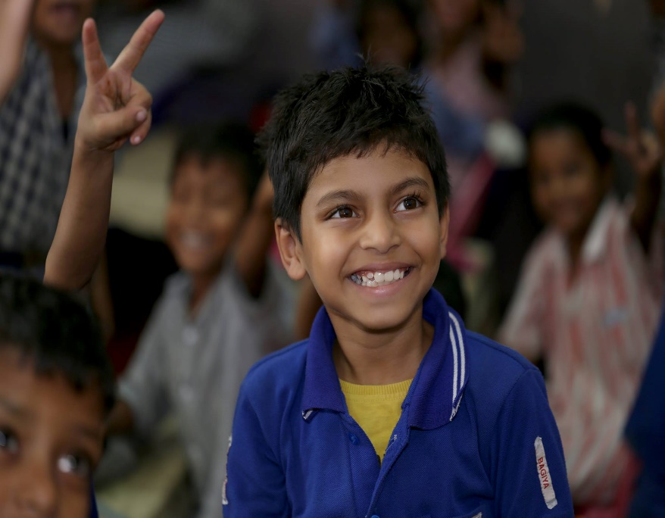
At BAGIYA – We aim to provide our students a complete holistic, moral and academic environment. The last few months saw the students get opportunities and shine in various fields from Sports to skill development. Below is a short journey of the students through the year. A lot is covered on our facebook group, page and Instagram.
The links are-
https://www.facebook.com/groups/bagiya/
https://www.facebook.com/Bagiya.SanshilFoundation/
#projectbagiya on Instagram

- Bagiya students participated by giving performances in Republic Day celebrations at South City 2 and Nirvana RWAs.
- Admission process begins in January to mainstream schools like
- DPS Shikshakenrdra
- Pallavanjali
- CD senior secondary school
- Amitasha (Amity afternoon school)
52 students admitted in mainstream for the academic year 2018-19 by March 2018.
- Our mainstreamed student Ruby (studying at CD senior secondary school) wins a prize with her team in a Everybody can design project competition by Steelcase, Gurgaon. The project was implemented for Government and low income group schools by Sanshil Foundation.
- Beginning of Skill development classes – Mehndi for overaged but academically weak students. The students have now progressed to glass painting and wood carving. Students have mastered Bridal, Arabian and Rajasthani style of Mehndi. This festive season – two students earned over 7000/- in a week. We were mindful of the fact that the students who set out to earn were over 14 yrs of age.
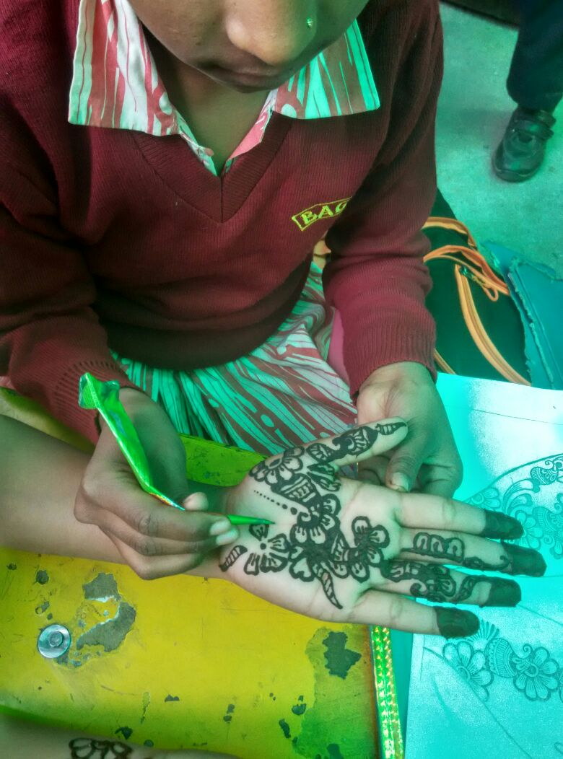
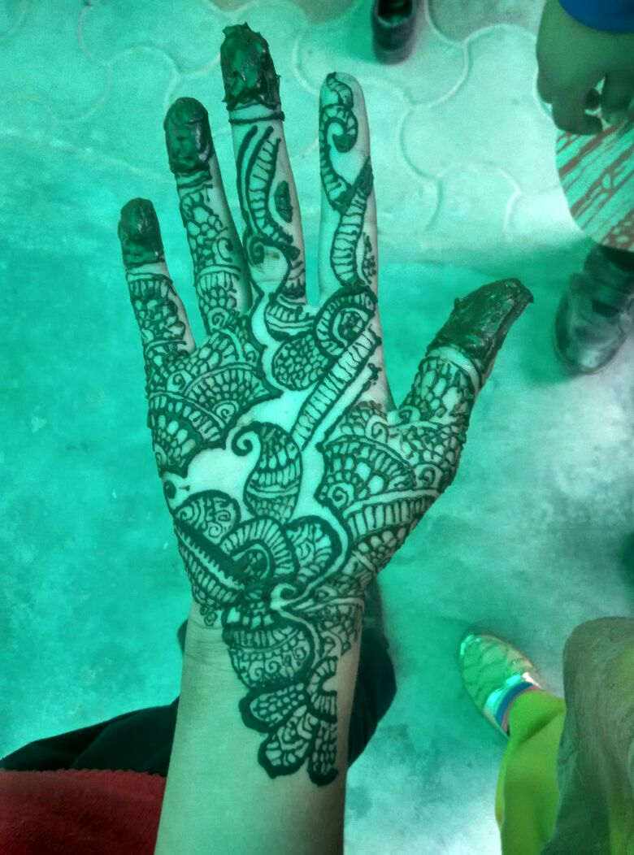
- Preparation of 3 km Marathon practice sessions with Volunteers of Make My Trip. Approximately 40 students from Bagiya participated in the Marathon and successfully completed it . This was exclusively for Bagiya by the IB students of Heritage school, Gurgaon.

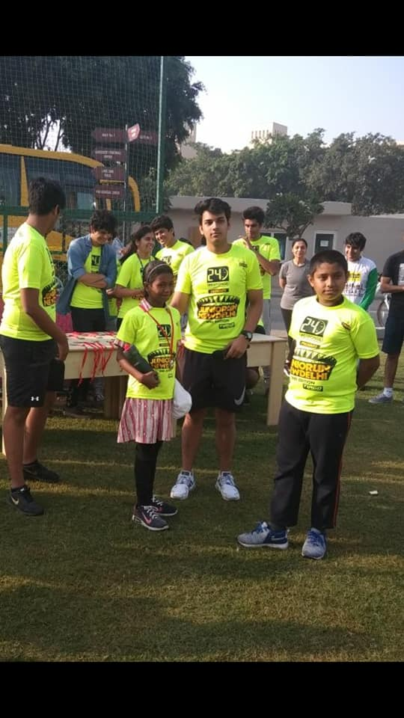
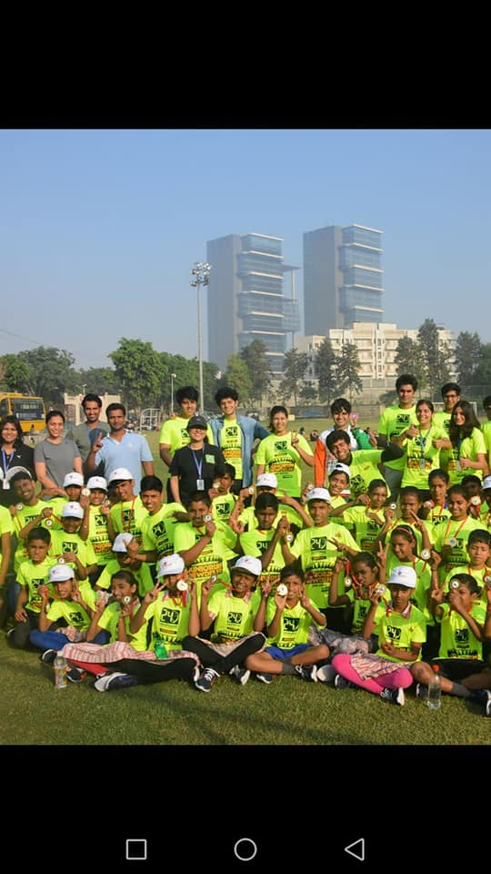

- Visit to Rashtrapati Bhavan for 50+ senior students. Prior to this visit, sessions were taken to make them aware of the historic monument and it’s importance.
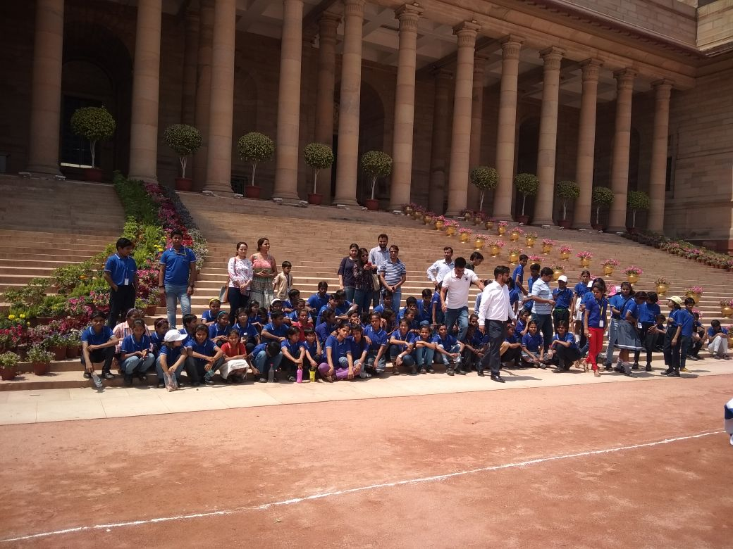
- Session on Good Touch Bad touch by volunteers of IMPA
- Visit to NSG, Manesar
- Visit to watch an IPL match – an opportunity for senior students.
- Session on dental hygiene
- Nukkad natak performance on Dengue awareness – Prevention and cure at various NDTV Behtar India events in many government schools pan Gurgaon
- Our Golfers who are coached by celebrity golfer Jyoti Randhawa , Golfer Digvijay Singh and team started playing tournaments for the first time. Pratima – our students from Bagiya who has also been mainstreamed won two tournaments recently in her age category.
- 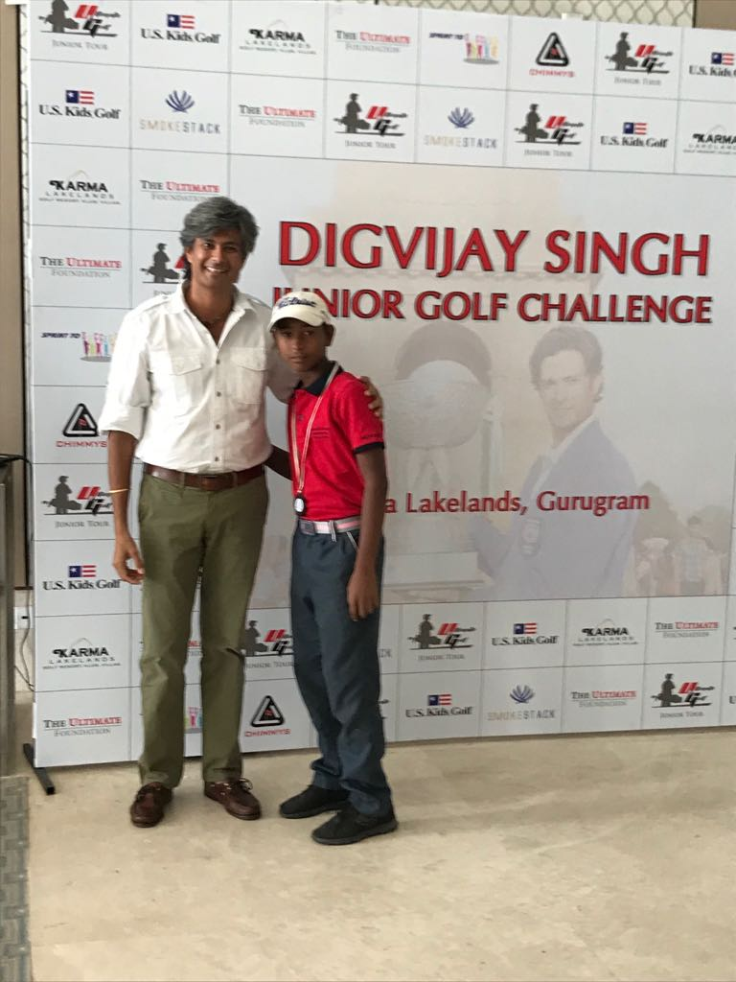
- Cleanliness and personal Hygiene workshops for children
- Pollution /control measures workshop for children
- Introduction of Changemakers module to 13 mainstreamed children.
Changemakers team joins protest in Gurgaon against felling of trees with I am Gurgaon.
Media coverage on BAGIYA in HT, TOI.
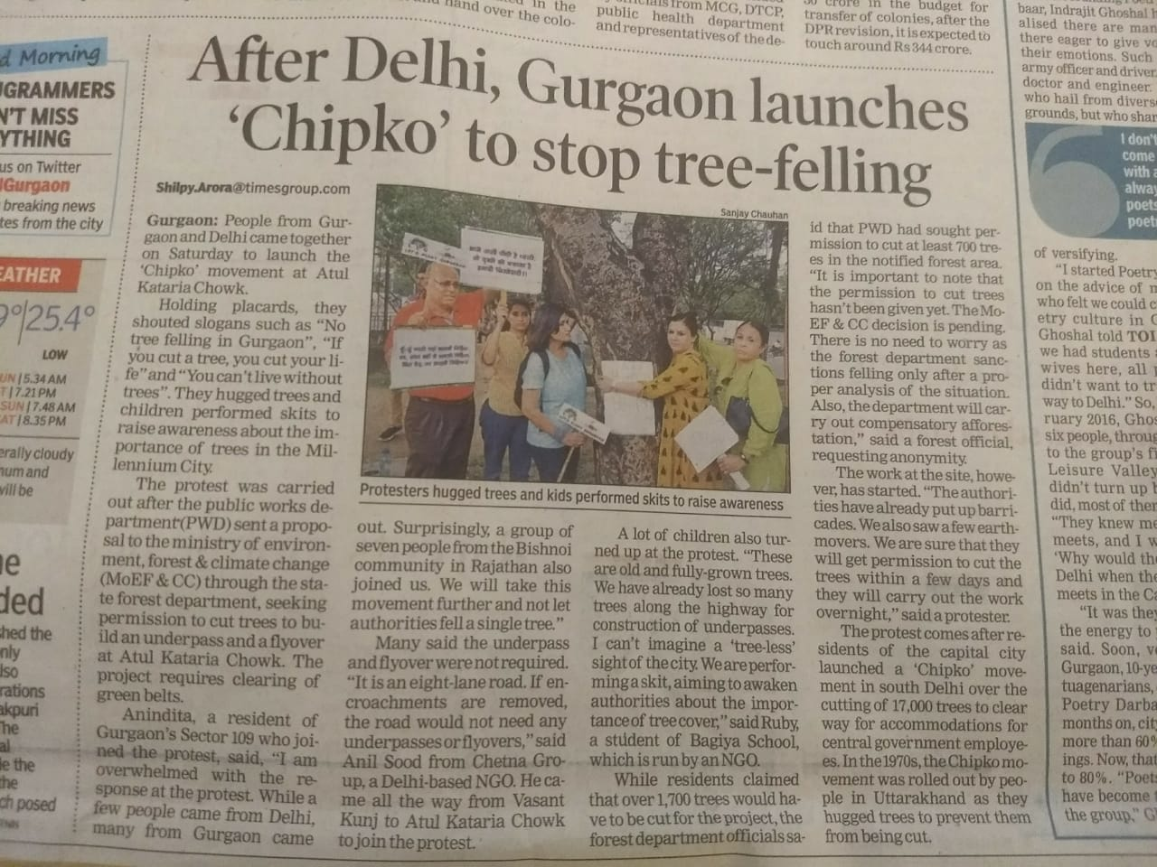
The Changemaker team participated in multiple anti pollution and anti plastic drives all over Gurgaon. They even met Officials of the Haryana state pollution control board requesting them to come strongly down on plastic bag manufacturers.
- August Kranti divas celebration at Gems school, Gurgaon. The children recited and performed on the epic
‘Khoob ladi mardani who to Jhansi waali rani thi”
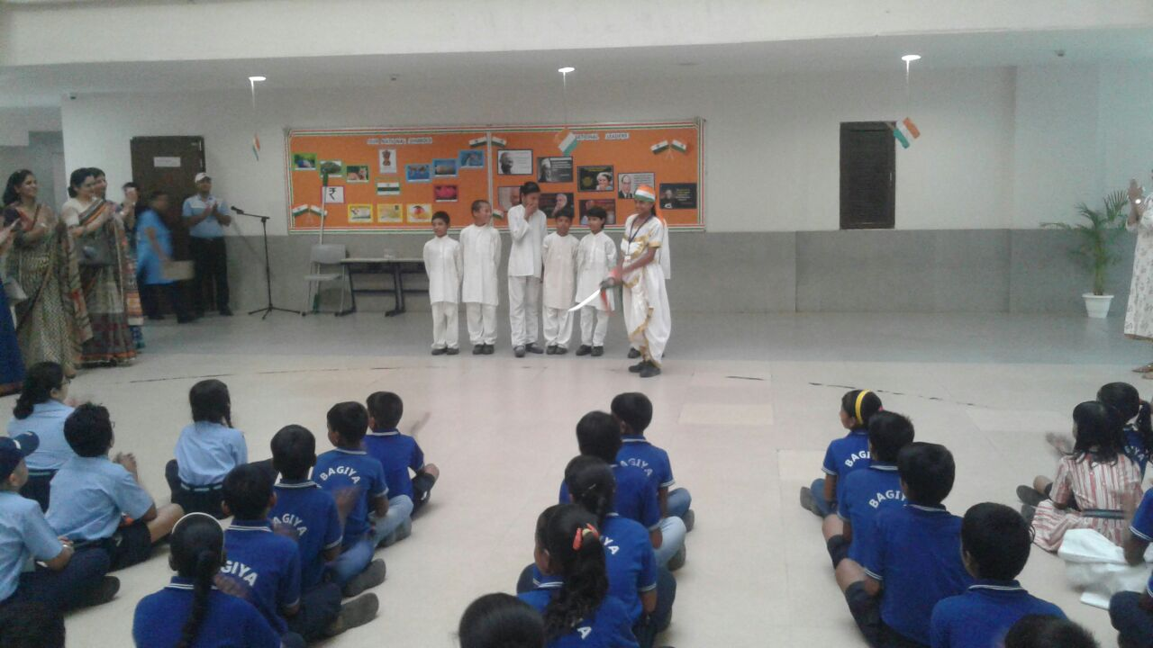
- Making rakhis and tying them
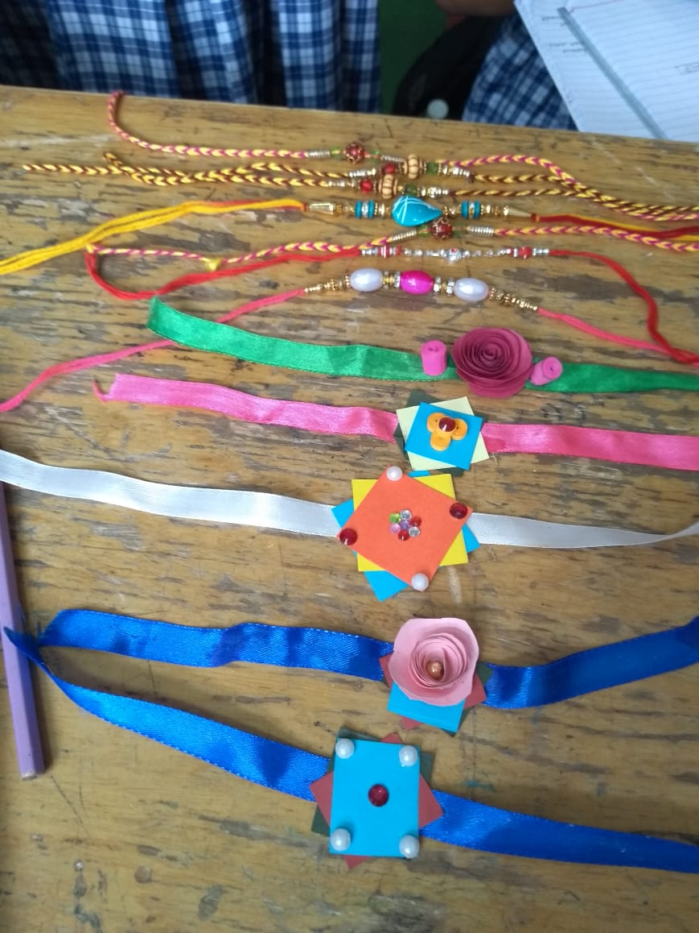

- Bharatnatyam dance taught by student volunteers gave the Bagiya students to give their first classical dance performance on Independence day.
- Independence day celebrations at Wembley estate, Nile, Nirvana and South City 2.
- Teachers day celebrations
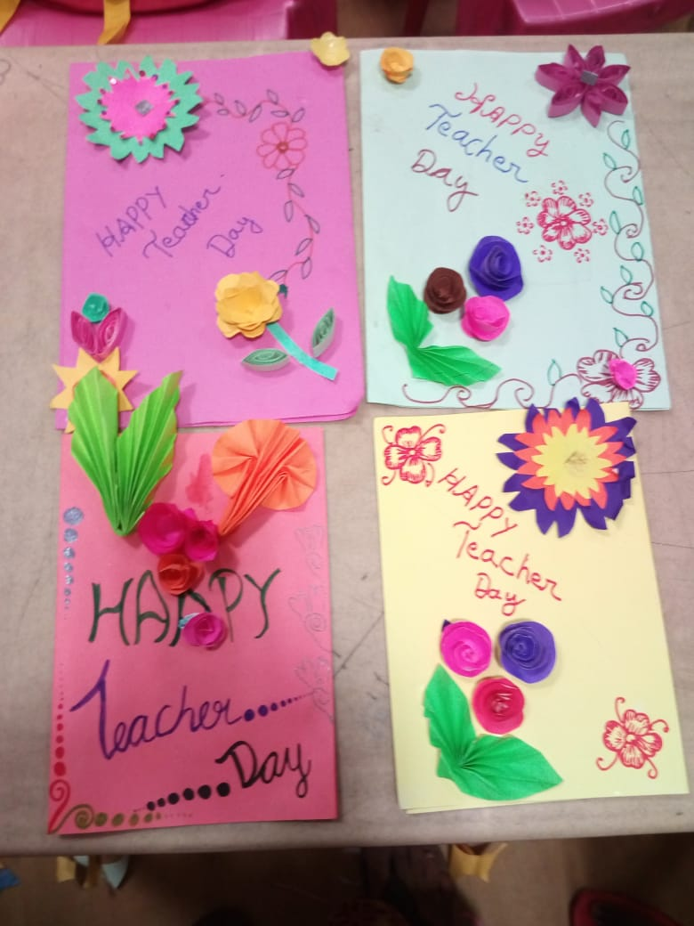
- Start of self-defense classes
- Paper bag making activity
- French program visit courtesy Sun City school
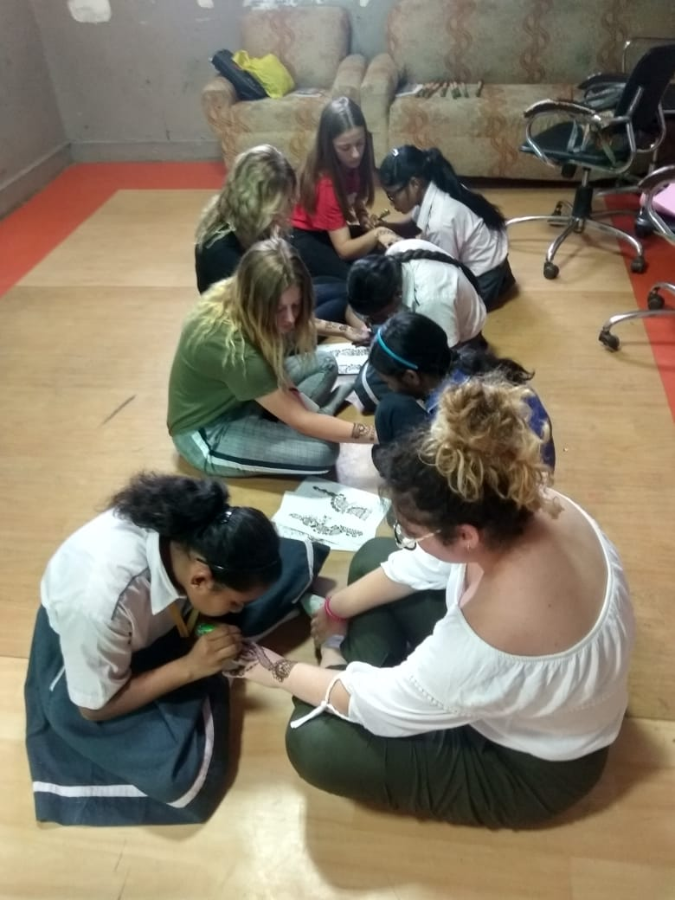
- DPS International and Lotus valley school monthly visits for CAS
- Certificate of appreciation received by Commissioner, MCG Gurgaon for the consistent work done by BAGIYA in the area of environment protection
- Rangoli competition
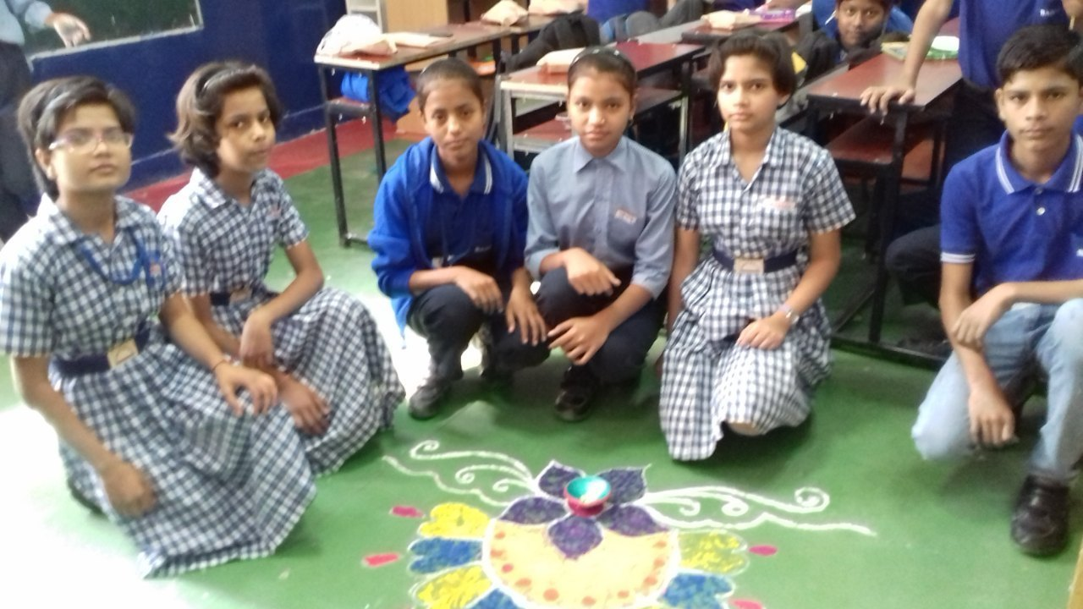
- No cracker workshops by volunteers
- Visit by SAP, Deloitte teams for Joy of Giving
- Children’s day celebrations

